Tessella Project Number: 5951
Tessella plc 26 The Quadrant, Abingdon Science Park, Abingdon, Oxfordshire, OX14 3YS, UK
T: +44 (0)1235 555511 | F: +44 (0)1235 553301 | E: info@tessella.com | www.tessella.com

Client: Rutherford Appleton Laboratory

Mantid
Event Workspace Detailed Design Document



Document Control
This document is under document control. All members of the distribution list will receive updated copies whenever alterations are made. All other copies are uncontrolled.

Document Owner
Name | Role | Company
Nicholas Draper | Owner | Tessella

Document Approval
The following are required to approve this document. Their approval signifies that the document is fit for purpose and approved for use. .
Name | Approval Role | Company
Freddie Akeroyd | Subject Expert | RAL
Peter Peterson | Subject Expert | ORNL

Distribution
Name | Role | Company
Mantid SVN repository | Filing | Rutherford Appleton Laboratory

Revision History
Author | Issue | Date | Description
Nicholas Draper | V1.R1.M0 | 21-Apr-2010 | 1st version written
Nicholas Draper | V1.R2.M0 | 05-May-2010 | Caching of Y and E values moved from EventHistogram into a MRUList in EventWorkspace. TimeStamp section added. More details on EventWorkspace and EventHistogram. Diagrams changed to JPEG format.

References
Document | Ref | Date | Details & Issue
Architectural Design Document | [ADD] | 11-Nov-2009 | V1.R2.M1
Table of Contents
1 Introduction 4
1.1 Definition of Terms 4
2 Detailed Design 5
2.1 Overview and Context 5
2.2 Event Based Data Structure 5
2.3 Handling of event based data files 6
2.4 EventWorkspace Design 7
2.5 Event Timestamps 9
2.6 Event based methods 9
2.7 Altering Event Workspaces 9
2.8 Performance 9

Introduction
Purpose of this DocumentThis document describes the detailed design of the Event Workspace component of the Mantid Framework.
It is based on the design specified in the Architectural Design Document [ADD]
It will form the basis of the development of this aspect of the framework and act as a guide for maintaining the system.
Scope of this DocumentThese requirements cover the development of the Event workspace aspect of the Mantid Framework.
Context of this IssueThis is the first draft of the EW-DDD derived from the ADD and after internal review will be updated and used as a basis for the development of the system.

Definition of Terms
ADD | The Architectural Design Document (this document), the high level design document for the entire system.
URD | The User Requirements Document, records the users’ requirements for the system.
SRD | The Software Requirements Document, specifies the behaviour of the software system.
API | Application Programming Interface, defines the interface through which two programs may interact.

Detailed Design

Overview and Context
Many facilities are now making use of event based data capture; This is already in use at the SNS at ORNL and is planned to be implemented at ISIS along with the next phase of instruments for TS2. Event based data allows the scientists much greater control over what data to include in their experiments and how to split it into periods. Crucially it also allows these decisions to be made, and changed after the experiment has completed.

The structure of this workspace within the workspace hierarchy is as follows, its inheritance from a Matrix Workspace is vital to allow its use in the majority of algorithms in Mantid.

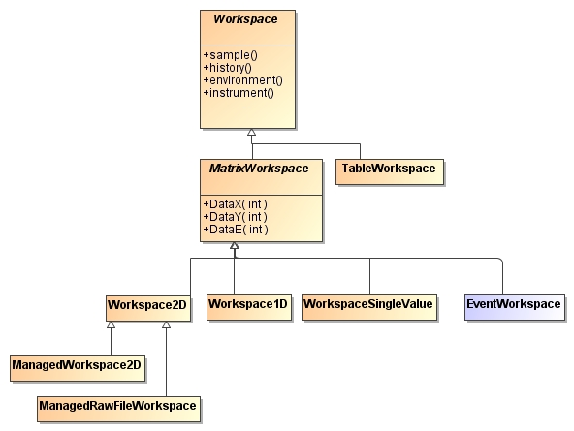

Event Based Data Structure
Event based data is fundamentally a long list of event as they were detected by the detectors. Each event carries with it information about which detector it was found at and a timestamp for when the event was detected.
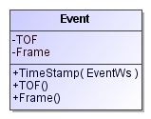
The nature of the timestamp information may well change dependent on the facility it was collected at. For example it may be a complete date/time record, or a relative offset to the start of the experiment, or the start of the frame in a pulsed source (in which case the events would also have information about which frame they were collected). However even if the information is outputted from the data acquisition differently it is possible to reconstruct either an absolute or relative timestamp from the data, as this is fundamental to event based data collection.

As with histogram based experiments there will also be associated log files with the event based data, however the ability to match each individual neutron to specific log values allows for much more details use of log values, both for filtering and splitting data into multiple periods.

The number of events recorded within a single experiment will be very large, and it is vital that we store and interact with this data efficiently.

Handling of event based data files
Event based data files may well come in a variety of formats, both in how they store the timestamp information for events, but also in the overall structure of the file. As such within Mantid we need to separate the loading of the data from the internal representation of the data in the same way as we have done for other workspaces within Mantid.
Therefore we will continue to use the same structure for data handling as we currently do. Specific Load algorithms will handle the loading of specific data formats and the translation of the data to the internal EventWorkspace data structure. Equally if required specific Save algorithms will be developed to save the data in an EventWorkspace. The LoadNexus and SaveNexus algorithms will be extended to recognize and forward requests correctly for Event-based Nexus files.
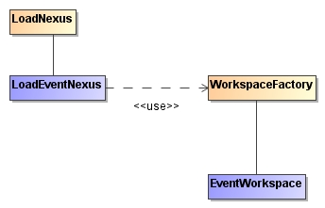

EventWorkspace Design
In order to allow maximum flexibility for using the EventWorkspace with the whole variety of Mantid Algorithms and data visualisation the EventWorkspace will inherit from the MatrixWorkspace abstract class. This forces it to support the readX, Y, E and data X, Y, E commands that allow you to access the data in a histogram like way, but it will allow the use of most of the functionality within Mantid automatically.
In order to explain this design it is best to first consider just the readX, Y, E methods, and assume that the workspace is read only. The diagram below shows an approach that could support this situation.

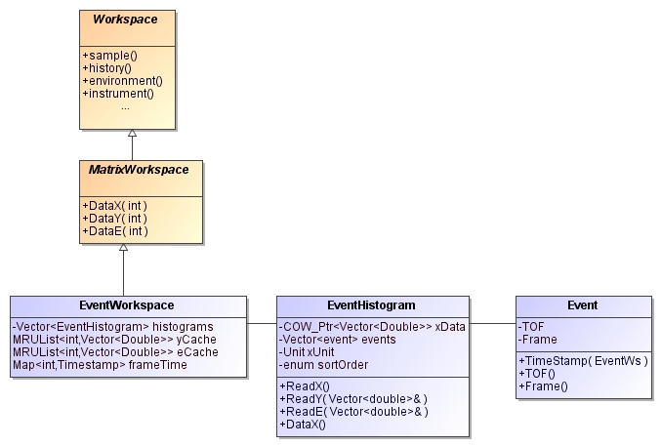

EventWorkspace
This class will own a vector of EventHistogram classes, and the same way as a Workspace2D holds a vector of Histogram1D classes. Here the ReadX, Y, R methods are redirected to the ReadX, Y, E methods in the corresponding eventHistogram
Member | Type | Description
histograms | A vector of pointers to EventHistogram instances | Each member contains the events seen by each detector
yCache | A most recently used list of vectors for storing cached y values | This is a buffer for the last calculated histogram of counts of events. The buffer will hold n histograms in a most recently used container, such that older histograms are naturally aged out of the buffer. This will actually store a composite object of the workspace index number and the vector itself.  The most recently used list structure is described in more detail below.  Even though the counts in the vectors will always be integers we will output this as doubles to adhere to the interface.
eCache | A most recently used list of vectors for storing cached y values | As above but storing the e values, which will in all cases be the square root of the values in the yCache.
xUnit | A pointer to a unit class | The current Unit that the xData values are in (TOF initially). This will allow for changes in units while remaining in an event workspace. The xData boundaries will be translated back into TOF before using them to recreate the y and e caches.
FrameTime | A map of Frame Index values (integers) against the accurate timestamp for the start of that frame | A map to allow the lookup of the frame start times against the frame index that will be stored in each event. Storing it this way decreases the volume of the timestamp that would otherwise need to be stored in each event.
Caching the eValues would be unnecessary if it were possible to override methods in stl::vector, but this is not possible. We could do it by wrapping all calls to std::vector and hiding it using the mantidvec typename, but this would have a much wider scope and impose a general performance penalty to everything. Given that the cache size will be relatively small (a default of 500, perhaps) then the volume of this data will be insignificant against the event data itself.

Most Recently Used Lists
We will use a most recently used (MRU) list structure to keep calculated histogram alive long enough for them to be used in algorithms. This caching approach is required as we provide references to this data as part of the MatrixWorkspace interface.
Whenever a call to ReadY, ReadE or the const versions of DataY and DataE the cache can be checked to see if the data is already in the cache, if it is it will be raised to the top of the MRU list. If the data is not in the MRU List then the lowest entry in the MRU List will be reused as the container for the requested data, that is to say that the workspace index number will be updated, and the vector refilled with the counts for the requested eventHistogram. This reuse will prevent the need to allocate and free memory during requests for data, and this will only be required on creation and deletion of the workspace itself.
The size of the caches will be user definable in the mantid.properties files, but should default to a reasonable value such as 500.

EventHistogram
Each EventHistogram instance represents all of the events collected for an individual detector, but allows it to be accessed at runtime either as event data, or as a read only Histogram representation that is calculated on the fly.
The vector of events would be sorted after population, initially to order the events in increasing TOF, this will improve performance when calculating the y or e values. However is should also be possible to sort the data in by Timestamp in order to optimise filtering operations, the current sorting criteria will be held in the sortOrder enum. The Y and E values will be calculated on demand. If the xData vector or unit is changed then the MRU caches of y and e values in the EventWorkspace will need to be cleared.

Members
Member | Type | Description
xData | COW pointer to a vector of doubles | This contains the x bin boundaries that will be used to Histogram the data on the fly.
events | A sorted (by TOF) vector of event instances | This contains all of the events seen by this detector
xUnit | A pointer to a unit class | The current Unit that the xData values are in (TOF initially). This will allow for changes in units while remaining in an event workspace.
sortOrder | An enum held in an unsigned char | Enum entries  - none  - time of flight  - timestamp

Incomplete list of functions
Function | Return type | Arguments | Description
readX | Const reference to the xData | None | Returns the xData vector reference.
readY | void | Reference to the vector to fill | Fills the provided vector with the calculated event histogram. The xData boundaries will be translated back into TOF from the current xUnit before using then to calculate the histogram.
readE | void | Reference to the vector to fill | As above, but fills the provided vector with the calculated error histogram.
This will approach will allow the EventWorkspace to support the MatrixWorkspace interface as well as allowing Rebinning and conversion of units within the EventWorkspace structure.

Event
The event class will be a minimal class that stores data about a single event within a detector. Given that you if you have two of the following you can calculate the third we will only store two of them to save space:
- Time of flight
- Frame start time
- Absolute time of detection
If we store Frame start times indexed to a FrameID within the Event Workspace we can store this as an unsigned int, also we can store the Time of flight as an unsigned int (in nanoseconds? Would allow frames up to 4 seconds) as well.
The Timestamp function requires access to the frameTime map in the eventWorkspace to be able to calculate the timestamp for this event, as such it requires a workspace reference to be provided as an argument.
With large numbers of small classes such as this it is very important to allocate them efficiently. The Boost.Pool classes can do this.

Event Timestamps
The precision of timestamps required for events is much greater than that provided by the default Date Time classes in C++. Resolution of these methods is often limited to microsecond, while with neutron event we require nanosecond resolution. We will have to investigate options for storing and comparing high resolution timestamps. The Boost DateTime classes are one possibility as these can be compiled to provide nanosecond resolution, but we need to see what the default compilation options are for Linux distributions. Otherwise we may have to provide our own implementation.

Event based methods
Alongside all of the Matrix workspace methods it is clear that the event workspace will have to support additional methods for when you want to interact with the data as events. The list of operations that will be required is not clear yet, but some of these can be anticipated.
- Filtering the events on Absolute time
- Filtering the events based on log values
- Splitting the workspace into periods on absolute time
- Splitting the workspace into periods on log values

Altering Event Workspaces
While conversion of units and rebinning can be handled natively within the eventWorkspace many other alterations will require the workspace to seamlessly transition to a Histogram workspace. To do this all interactions with an event based workspace will not be directly with the workspace class itself, instead they will be forwarded by a WorkspaceProxy class. This will allow the class to seamlessly convert its data storage to a Workspace2D should an algorithm take a non const reference or access one of the DataX, Y E commands in non const way. This will allow Algorithms to access the workspace without having to treat it especially as an EventWorkspace.

Performance
It is clear that with on the fly histogramming this will not be as fast as pre histogrammed data, and there is much to test in the choice of container classes etc. As such it will be important to perform a life size test of the performance of this structure as soon as possible.

